Lens-Shaped Figure

Definition
# Source: AI Source: Provided by: [Data Path: Persons Table -> ID Column: 1, Name_En Column: Motasem Essam] -> From: [ChatGPT] on [7/25/2026]
A Lens-Shaped Figure (or Geometric Lens) is a convex plane region bounded by two circular arcs joined at their two endpoints. It can be formed by the intersection of two circular disks.
Lens-Shaped Figure = A region enclosed by two curved arcs that meet at two distinct points.
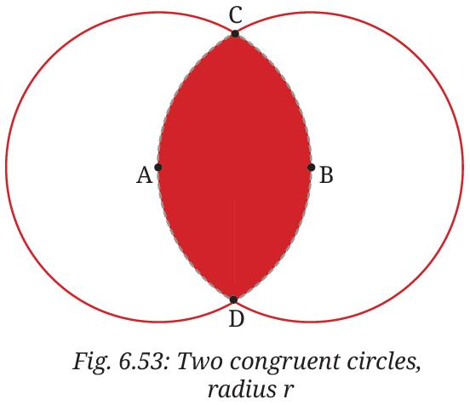
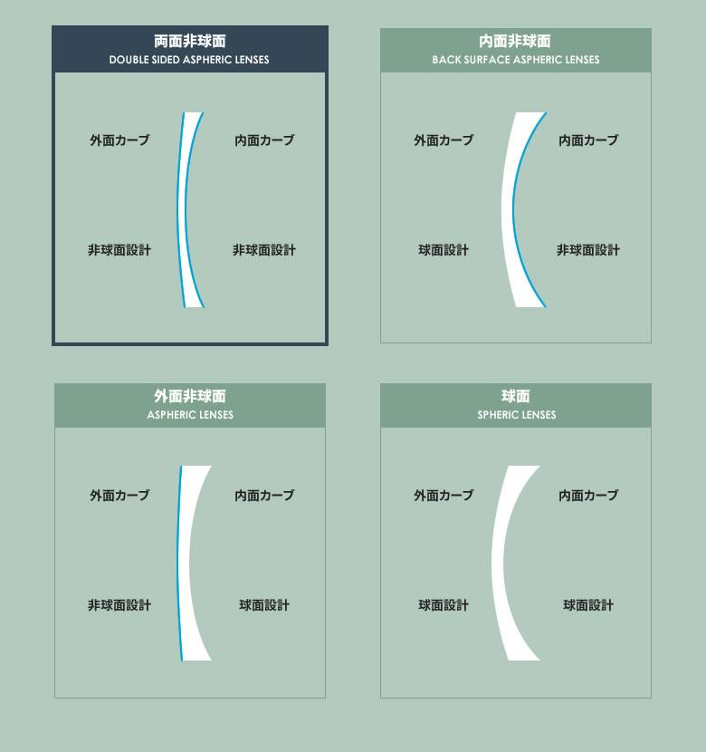
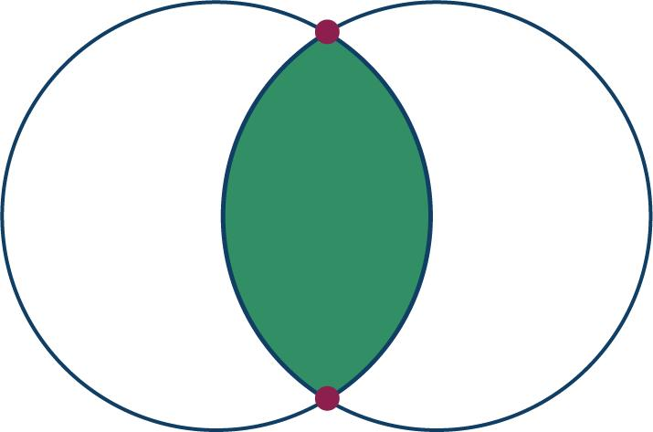

Fundamental Concept
# Source: AI Source: Provided by: [Data Path: Persons Table -> ID Column: 1, Name_En Column: Motasem Essam] -> From: [ChatGPT] on [7/25/2026]
A lens-shaped figure commonly forms when two circles intersect at two distinct points.
Let the intersection points be $A$ and $B$.
- The first circular arc connects $A$ to $B$.
- The second circular arc connects $A$ to $B$.
- Together, the two arcs enclose the lens-shaped region.
The boundary is a closed curve, even though each individual arc is open.

Basic Structure
# Source: AI Source: Provided by: [Data Path: Persons Table -> ID Column: 1, Name_En Column: Motasem Essam] -> From: [ChatGPT] on [7/25/2026]
Shapes
└── Plane Shapes
└── Curvilinear Shapes
└── Lens-Shaped Figure
A lens-shaped figure generally consists of:
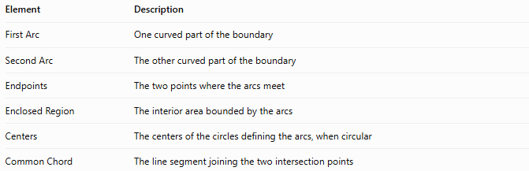
Element | Description
First Arc | One curved part of the boundary
Second Arc | The other curved part of the boundary
Endpoints | The two points where the arcs meet
Enclosed Region | The interior area bounded by the arcs
Centers | The centers of the circles defining the arcs, when circular
Common Chord | The line segment joining the two intersection points

Mathematical Representation
# Source: AI Source: Provided by: [Data Path: Persons Table -> ID Column: 1, Name_En Column: Motasem Essam] -> From: [ChatGPT] on [7/25/2026]
For two circles with centers $\left(a_{1},b_{1}\right)$ and $\left(a_{2},b_{2}\right)$, and radii $r_{1}$ and $r_{2}$, their equations are
$${\left(x-a_{1}\right)}^{2}+{\left(y-b_{1}\right)}^{2}=r_{1}^{2}$$
$${\left(x-a_{2}\right)}^{2}+{\left(y-b_{2}\right)}^{2}=r_{2}^{2}$$
The lens-shaped region is the intersection of the two disks:
$$\boxed{L=D_{1}∩D_{2}}$$
where $D_{1}$ and $D_{2}$ represent the filled circular regions.

Main Types of Lens-Shaped Figures

1. Symmetric Lens
# Source: AI Source: Provided by: [Data Path: Persons Table -> ID Column: 1, Name_En Column: Motasem Essam] -> From: [ChatGPT] on [7/25/2026]
A lens whose two boundary arcs have equal radii, producing a figure with a reflection axis along the line joining the circle centers.
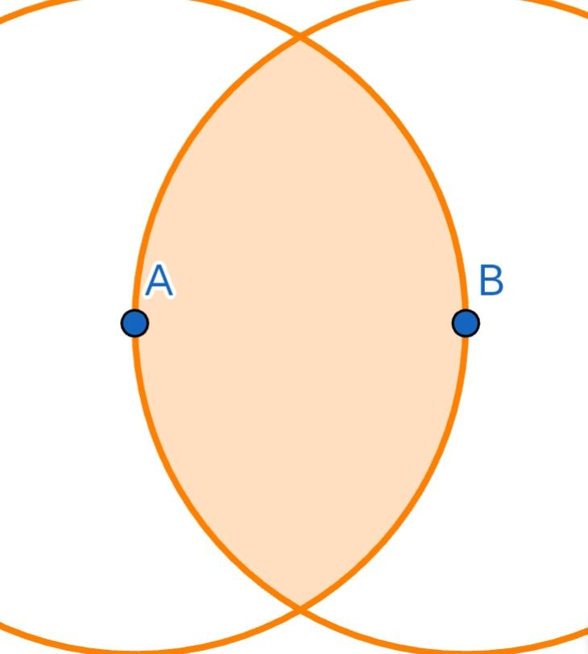

2. Asymmetric Lens
# Source: AI Source: Provided by: [Data Path: Persons Table -> ID Column: 1, Name_En Column: Motasem Essam] -> From: [ChatGPT] on [7/25/2026]
A lens whose boundary arcs have different radii. It generally lacks the symmetry of an equal-radius lens.
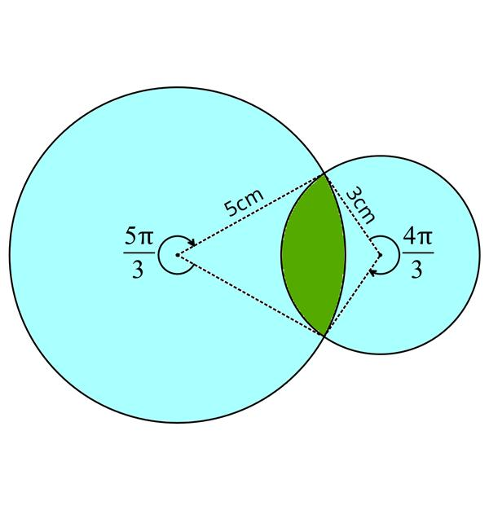

3. Circular Lens
# Source: AI Source: Provided by: [Data Path: Persons Table -> ID Column: 1, Name_En Column: Motasem Essam] -> From: [ChatGPT] on [7/25/2026]
A lens bounded by two circular arcs. This is the standard lens studied in plane geometry.
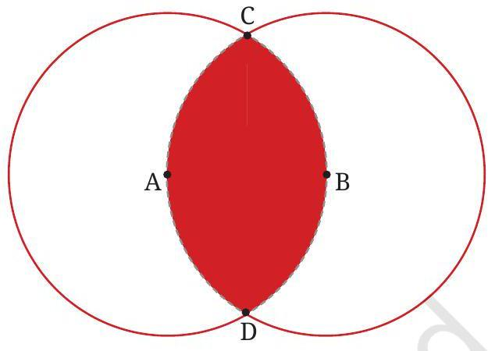

Perimeter and Area
# Source: AI Source: Provided by: [Data Path: Persons Table -> ID Column: 1, Name_En Column: Motasem Essam] -> From: [ChatGPT] on [7/25/2026]
The perimeter of a lens is the sum of the lengths of its two boundary arcs:
$$\boxed{P=L_{1}+L_{2}}$$
where $L_{1}$ and $L_{2}$ are the respective arc lengths.
The area depends on the radii and the positions of the two circles. For a circular lens, it can be calculated by adding the two relevant circular-segment areas.
For two equal circles of radius $r$, whose centers are separated by distance $d$, the intersection area is
$$\boxed{A=2r^{2}\cos^{-1}\left(\frac{d}{2r}\right)-\frac{d}{2}\sqrt{4r^{2}-d^{2}}}$$
This formula applies when \(0<d<2r\).

Lens-Shaped Figure vs Circle
# Source: AI Source: Provided by: [Data Path: Persons Table -> ID Column: 1, Name_En Column: Motasem Essam] -> From: [ChatGPT] on [7/25/2026]
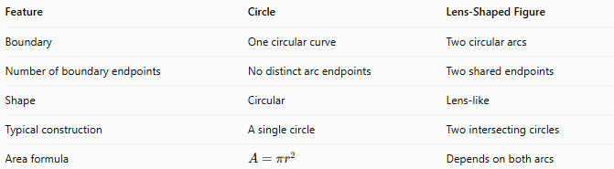
Feature | Circle | Lens-Shaped Figure
Boundary | One circular curve | Two circular arcs
Number of boundary endpoints | No distinct arc endpoints | Two shared endpoints
Shape | Circular | Lens-like
Typical construction | A single circle | Two intersecting circles
Area formula | $$A=πr^{2}$$ | Depends on both arcs

Key Points
# Source: AI Source: Provided by: [Data Path: Persons Table -> ID Column: 1, Name_En Column: Motasem Essam] -> From: [ChatGPT] on [7/25/2026]
- A lens-shaped figure is a convex plane region bounded by two circular arcs.
- The two arcs meet at two distinct endpoints.
- It can be formed by intersecting two circular disks.
- A symmetric lens has equal-radius arcs; an asymmetric lens has unequal-radius arcs.
- The vesica piscis is a special type of symmetric lens.

Conclusion
# Source: AI Source: Provided by: [Data Path: Persons Table -> ID Column: 1, Name_En Column: Motasem Essam] -> From: [ChatGPT] on [7/25/2026]
A Lens-Shaped Figure is a curvilinear geometric region enclosed by two circular arcs that meet at two distinct endpoints. Its main geometric properties include its boundary arcs, symmetry, perimeter, and enclosed area.

